Quality Assuring the ESR
Finally, it is worth remembering that your report will be subject to scrutiny by the Deanery and RCGP. At least 10% of the ESRs that have been deemed satisfactory will be reviewed for quality assurance purposes. The following criteria are used for the assessment:
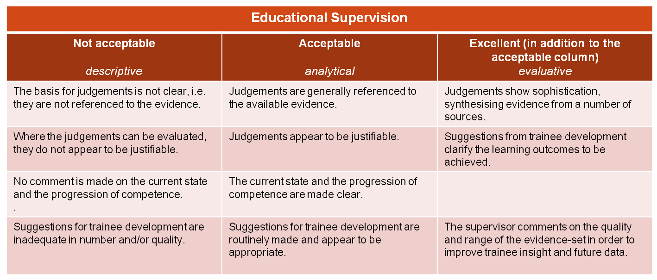

The most common feedback comments from the panels for the less than acceptable ESRs are listed in the table below.

- Evidence quoted but does not justify the competency rating. Excellent progress does not equate to competency rating of excellent.
- No links to evidence. No competencies linked to log entries
- Competency ratings show minimal comments with no linkage to evidence. Other comments in the ESR are also minimalistic.
- No links to evidence to justify rating.
- No comment under making a diagnosis + more than 2 months before end of review.
- Not evidence based. Poor linkage to competencies. No specific development points raised.
- Linkage to competences poor, no comment on quality of trainees log.
- No specific linkage to evidence

A penny for your thoughts…

The ARCP panels are, in essence, quality assuring the Educational Supervisors.
The Educational Supervisors are, in essence, quality assuring the Clinical Supervisors.
The Clinical Supervisors are, in essence, quality assuring the trainees.
Is this quality assurance overload?
Nick Price (TPD, Bradford)

